The following program tries to print student’s letter grade based on number grade. What is wrong with the code? (Don’t look for syntax errors)

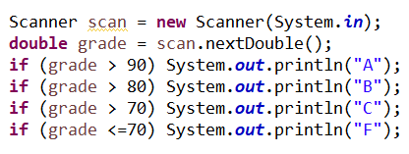

Given an integer array nums, the following code should print two numbers that are equal in value but in opposite signs (positive and negative number). Complete the code:

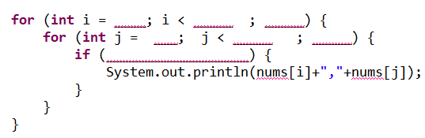

Given an integer array nums, explain what the following code is trying to do:

